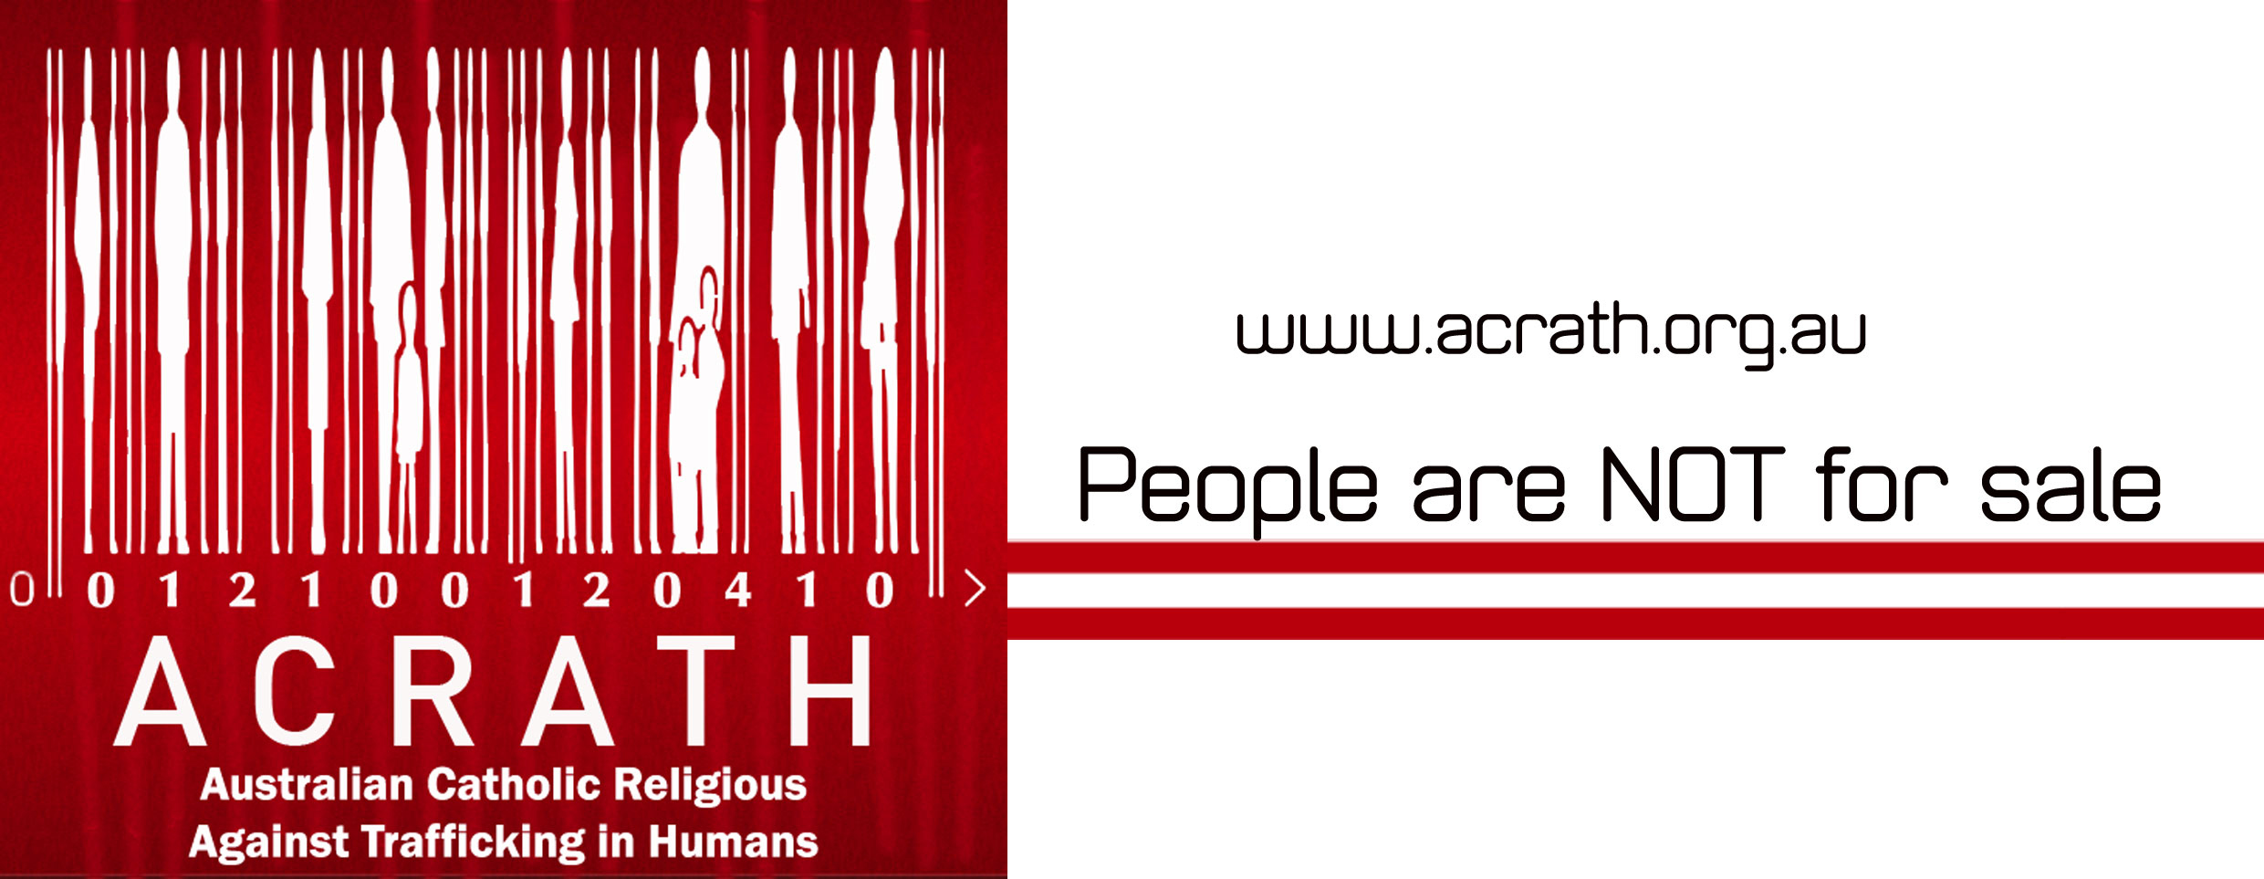

News Release …February 2016
End Slavery in your School, Parish and Community
Make Your Easter Chocolate Slavery Free – Please!
“Every person ought to have the awareness that purchasing is always a moral – and not simply an economic – act.” Pope France 2015
School students and parish communities are being urged to eat only slavery-free chocolate this Easter and not buy Easter eggs and chocolate that might have been produced using child labour from West Africa.
The Slavery-Free Easter Chocolate Campaign, a *coalition of social justice groups, is asking people to buy only chocolate that carries a label (FAIRTRADE, Rainforest Alliance and UTZ certified) showing that the cocoa beans used in the chocolate’s production has been sourced ethically, from farmers who engage in good labour practices.
The International Labor Rights Forum (ILRF) estimates that there are about 1.5 million children working in the cocoa sector in West Africa, many of whom have been enslaved, or forced to work in exploitative conditions.
Christine Carolan, the Executive Officer of ACRATH (Australian Catholic Religious Against Trafficking in Humans), one of the Slavery-Free Easter Chocolate Campaign members, said buying slavery-free chocolate at Easter gave people the opportunity to take a stand against human trafficking and slavery.
“We know that some children, working in some of the cocoa farms in West Africa are trafficked. Many others work in dangerous conditions for little or no wages and cannot attend school,” Ms Carolan said.
“Students in Australia may be a world away from the slavery of West Africa, but they are in a position to affect change and show solidarity with children who cannot go to school and who cannot afford to buy or eat chocolate.”
One of the important decisions schools can made during Lent is to use only slavery-free chocolate in any fundraising and chocolate drives.
Ms Carolan urged schools and parishes to check with suppliers before they committed to any chocolate fundraising boxes.
“If it isn’t slavery-free chocolate we urge you to ask for slavery-free chocolate. The more schools ask, the more available it will become,” she said.
A decade ago there was almost no slavery-free chocolate sold in Australia. The global movement, led by many groups in Australia, has seen a dramatic increase in the availability of slavery -free chocolate, and other products, for consumers.
Ms Carolan said many supermarkets in Australia are selling slavery-free chocolate this Easter and great gains have been made in recent years, including:
- Cadbury dairy milk blocks and bars made in Australia are FAIRTRADE
- All Mars bars made in Australia are now Rainforest Alliance
- All Nestle chocolate made in Australia and NZ is now UTZ certified
- Aldi supermarkets have a wide variety of UTZ certified Easter chocolate, and
- Haigh’s Easter range of chocolates are all UTZ certified.
“The supermarkets are slowly coming to the party, but we can do better. We want to make all the chocolate in our supermarkets and stores slavery-free,” Ms Carolan said.
She urged consumers this Easter to do five things:
- Buy only slavery free chocolate – use your buying power to take a stand.
- Eat only slavery free chocolate. If your local/favourite shop doesn’t sell slavery free chocolate then ask them to please start stocking it.
- Find out about cocoa bean production and the plight of many children in chocolate production.
- Thank the managers of stores that are stocking slavery-free chocolate this Easter.
- Discuss your slavery-free chocolate decision with five other people to help spread the word.
To find out more about the campaign and slavery free chocolate please go to www.acrath.org.au.
* Slavery-Free Easter Chocolate Campaign coalition members include ACRATH - Australian Catholic Religious Against Trafficking in Humans, CARITAS Australia - Archdiocese of Melbourne, Catholic Diocese of Ballarat - Social Justice Commission, Catholic Archdiocese of Melbourne - Office for Justice and Peace, Catholic Diocese of Sandhurst - Social Justice Committee, Uniting Church in Australia - Synod of Victoria & Tasmania, Victorian Council of Churches - Social Questions Commission.
What to Look for
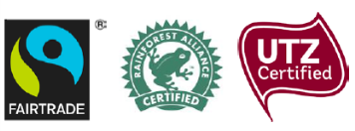
Slavery-free chocolate carries one of these three labels - FAIRTRADE, Rainforest Alliance or UTZ certified. This shows that the cocoa beans used in the chocolate’s production have been sourced ethically, from farmers who engage in good labour practices.

Media Contact: Rosie Hoban on 0431 471 046 or Christine Carolan 0427 302 755

